**EXP 1:**

**Write A C Program To Simulate A Deterministic Finite Automata (Dfa) For The Given Language Representing Strings That Start With A And End With A**

**Program:**

#include<stdio.h>

#include<string.h>

#define max 20

int main()

{

int trans_table[4][2]={{1,3},{1,2},{1,2},{3,3}};

int final_state=2,i;

int present_state=0;

int next_state=0;

int invalid=0;

char input_string[max];

printf("Enter a string:");

scanf("%s",input_string);

int l=strlen(input_string);

for(i=0;i<l;i++)

{

if(input_string[i]=='a')

next_state=trans_table[present_state][0];

else if(input_string[i]=='b')

next_state=trans_table[present_state][1];

else

invalid=l;

present_state=next_state;

}

if(invalid==l)

{

printf("Invalid input");

}

else if(present_state==final_state)

printf("dontAccept\n");

else

printf("Accept\n");

}

**Output:**

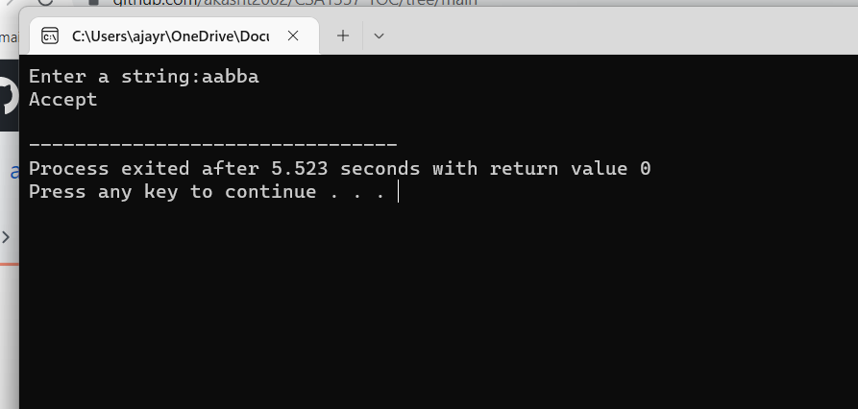

**Exp2:**

Write A C Program To Simulate A Deterministic Finite Automata (Dfa) For The Given Language Representing Strings That Start With 0 And End With 1

**Program:**

#include<stdio.h>

#include<string.h>

#define max 20

int main()

{

int trans_table[4][2]={{1,3},{1,2},{1,2},{3,3}};

int final_state=2,i;

int present_state=0;

int next_state=0;

int invalid=0;

char input_string[max];

printf("Enter a string:");

scanf("%s",input_string);

int l=strlen(input_string);

for(i=0;i<l;i++)

{

if(input_string[i]=='0')

next_state=trans_table[present_state][0];

else if(input_string[i]=='1')

next_state=trans_table[present_state][1];

else

invalid=l;

present_state=next_state;

}

if(invalid==l)

{

printf("Invalid input");

}

else if(present_state==final_state)

printf("Accept\n");

else

printf("dont Accept\n");

}

**Output:**

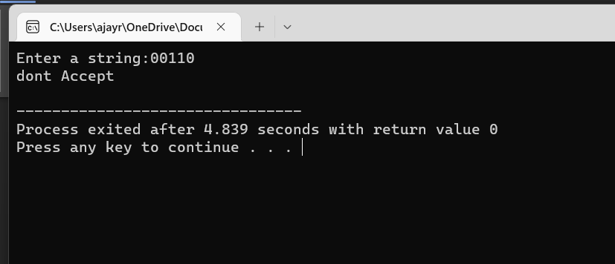

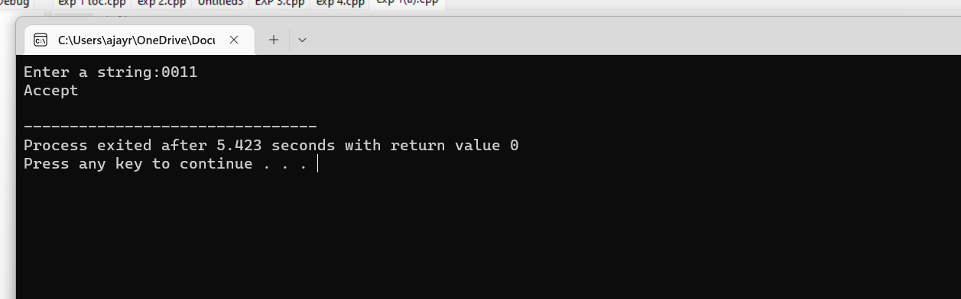

**Exp 3;**

Write a C program to check whether a given string belongs to the language deined by a Context Free Grammar (CFG) S → 0A1 A → 0A | 1A | ε

**Program:**

#include<stdio.h>

#include<string.h>

int main(){

char s[100];

int i,flag;

int l;

printf("enter a string to check:");

scanf("%s",s);

l=strlen(s);

flag=1;

for(i=0;i<l;i++)

{

if(s[i]!='0' && s[i]!='1')

{

flag=0;

}

}

if(flag!=1)

printf("string is Not Valid\n");

if(flag==1)

{

if (s[0]=='0'&&s[l-1]=='1')

printf("string is accepted\n");

else

printf("string is Not accepted\n");

}

}

**Output:**

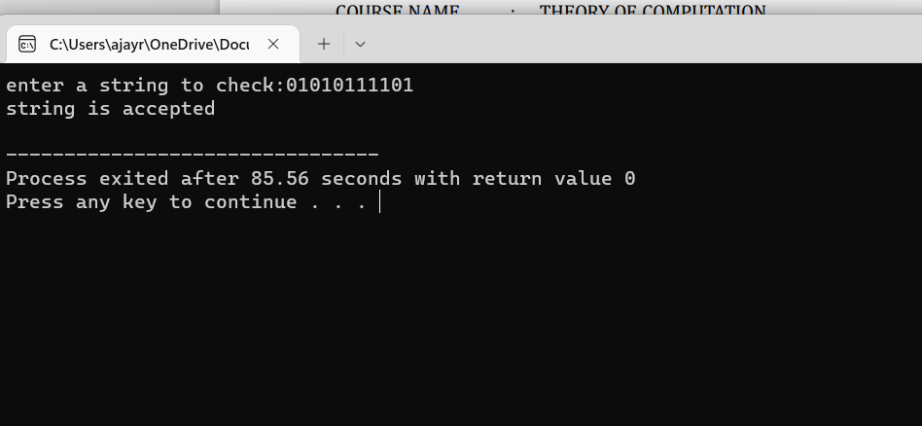

**Exp 4:**

Write a C program to check whether a given string belongs to the language deined by a Context Free Grammar (CFG) S → 0S0 | 1S1 | 0 | 1 | ε

**Program:**

#include<stdio.h>

#include<string.h>

int main()

{

char s[100];

int i,flag,flag1,a,b;

int l;

printf("enter a string to check:");

scanf("%s",s);

l=strlen(s);

flag=1;

for(i=0;i<l;i++)

{

if(s[i]!='0' && s[i]!='1')

{

flag=0;

}

}

if(flag!=1)

printf("string is Not Valid\n");

if(flag==1)

{

flag1=1;

a=0;b=l-1;

while(a!=(l/2))

{

if(s[a]!=s[b])

{

flag1=0;

}

a=a+1;

b=b-1;

}

if (flag1==1)

{

printf("The string is a palindrome\n");

printf("string is accepted\n");

}

else

{

printf("The string is not a palindrome\n");

printf("string is Not accepted\n");

}

}

}

Output:

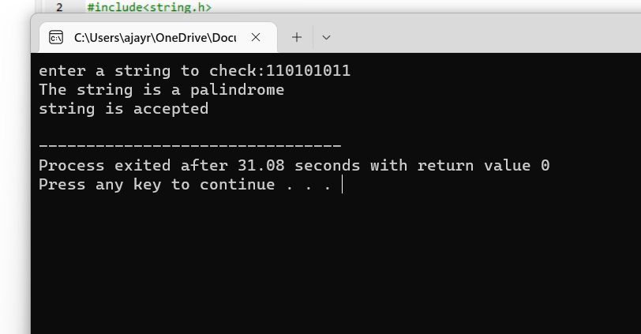

**EXP 5**

Write a C program to check whether a given string belongs to the language deined by a Context Free Grammar (CFG) S → 0S0 | A A → 1A | ε

**Program:**

#include<stdio.h>

#include<string.h>

int main()

{

char s[100];

int i,flag,flag1,a,b;

int l,count1,count2;

printf("enter a string to check:");

scanf("%s",s);

l=strlen(s);

flag=1;

for(i=0;i<l;i++)

{

if(s[i]!='0' && s[i]!='1')

{

flag=0;

}

}

if(flag!=1)

printf("string is Not Valid\n");

if(flag==1)

{

i=0;count1=0;

while(s[i]=='0') // Count the no of 0s in the front

{

count1++;

i++;

}

while(s[i]=='1')

{

i++; // Skip all 1s

}

flag1=1;

count2=0;

while(i<l)

{

if(s[i]=='0')// Count the no of 0s at the end

{

count2++;

}

else

{

flag1=0;

}

i++;

}

if(flag1==1)

{

if(count1==count2)

{

printf("The string satisfies the condition 0n1m0n\n");

printf("String Accepted\n");

}

else

{

printf("The string does not satisfy the condition 0n1m0n\n");

printf("String Not Accepted\n");

}

}

else

{

printf("The string does not satisfy the condition 0n1m0n\n");

printf("String Not Accepted\n");

}

}

}

**Output:**

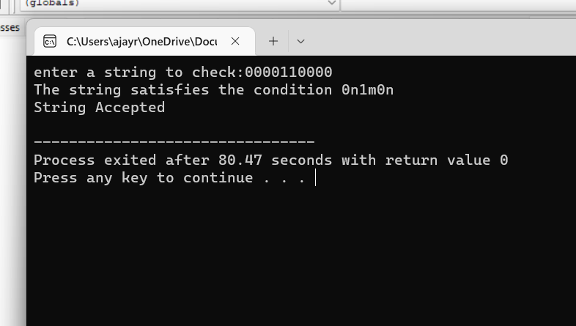

**Exp 6;**

. Write a C program to check whether a given string belongs to the language deined by a Context Free Grammar (CFG) S → 0S1 | ε

**Program;**

#include<stdio.h>

#include<string.h>

int main()

{

char s[100];

int i,flag,flag1,flag2;

int l;

printf("enter a string to check:");

scanf("%s",s);

l=strlen(s);

flag=1;

for(i=0;i<l;i++)

{

if(s[i]!='0' && s[i]!='1')

{

flag=0;

}

}

if(flag!=1)

printf("string is Not Valid\n");

if(flag==1)

{

if(l%2!=0) // If string length is odd

{

printf("The string does not satisfy the condition 0n1n\n");

printf("String Not Accepted\n");

}

else

{

// To check first half contains 0s

flag1=1;

for(i=0;i<(l/2);i++)

{

if(s[i]!='0')

{

flag1=0;

}

}

// To check second half contains 1s

flag2=1;

for(i=l/2;i<l;i++)

{

if(s[i]!='1')

{

flag2=0;

}

}

if(flag1==1 && flag2==1)

{

printf("The string satisfies the condition 0n1n\n");

printf("String Accepted\n");

}

else

{

printf("The string does not satisfy the condition 0n1n\n");

printf("String Not Accepted\n");

}

}

}

}

**Output:**

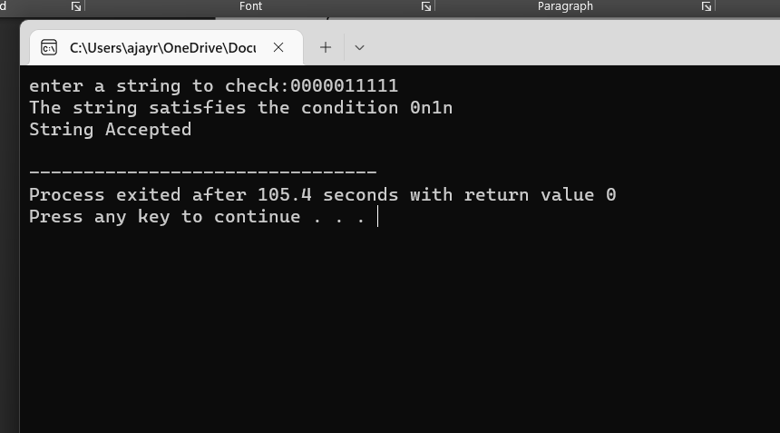

**Exp 7:**

Write a C program to check whether a given string belongs to the language deined by a Context Free Grammar (CFG) S → A101A, A → 0A | 1A | ε

**Program;**

#include<stdio.h>

#include<string.h>

int main()

{

char s[100];

int i,flag,flag1;

int l;

printf("enter a string to check:");

scanf("%s",s);

l=strlen(s);

flag=1;

for(i=0;i<l;i++)

{

if(s[i]!='0' && s[i]!='1')

{

flag=0;

}

}

if(flag==1)

printf("string is Valid\n");

else

printf("string is Not Valid\n");

if(flag==1)

{

flag1=0;

for(i=0;i<l-2;i++)

{

if(s[i]=='1')

{

if(s[i+1]=='0' && s[i+2]=='1')

{

flag1=1;

printf("Substring 101 exists. String accepted\n");

break;

}

}

}

if(flag1==0)

printf("Substring 101 does not exist. String not accepted\n");

}

}

**Output:**

